**NGINX CODE:-**

apiVersion: apps/v1  
kind: Deployment  
metadata:  
  name: nginx-login  
spec:  
  replicas: 1  
  selector:  
    matchLabels:  
      app: nginx-login  
  template:  
    metadata:  
      labels:  
        app: nginx-login  
    spec:  
      containers:  
      - name: nginx-login  
        image: nginx:latest  # Public Nginx image from Docker Hub  
        ports:  
        - containerPort: 80  
---  
apiVersion: v1  
kind: Service  
metadata:  
  name: nginx-login-service  
spec:  
  type: NodePort  
  selector:  
    app: nginx-login  
  ports:  
    - protocol: TCP  
      port: 80  
      targetPort: 80  
      nodePort: 30008  # NodePort must be in the range 30000-32767

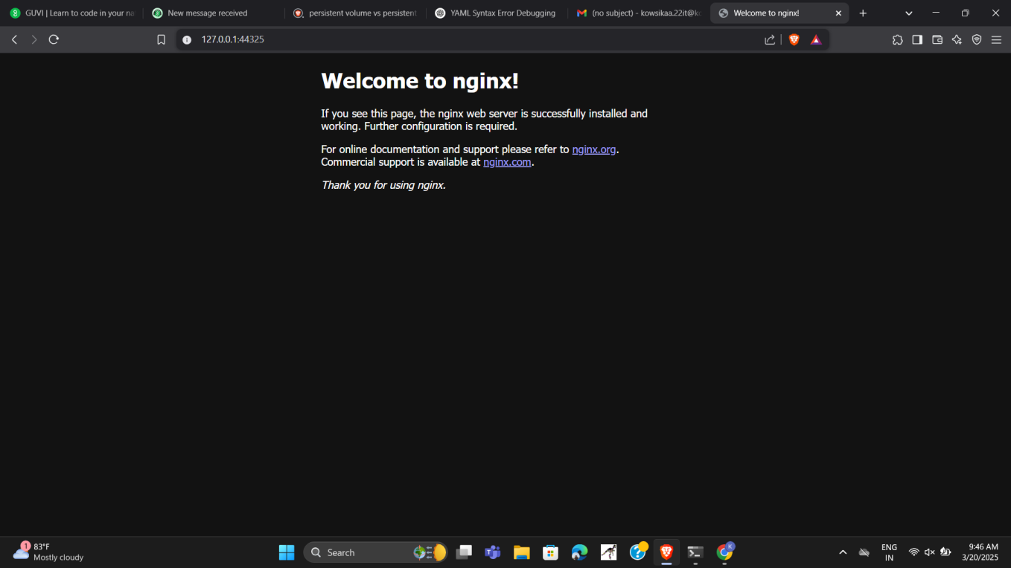

**MY CUSTOM NGINX CODE RUNNING LOCALHOST:9000**

echo '<h1>Welcome to Kowsika’s Custom Nginx Page!</h1>' > index.html

echo -e "FROM nginx\nCOPY index.html /usr/share/nginx/html/index.html" > Dockerfile

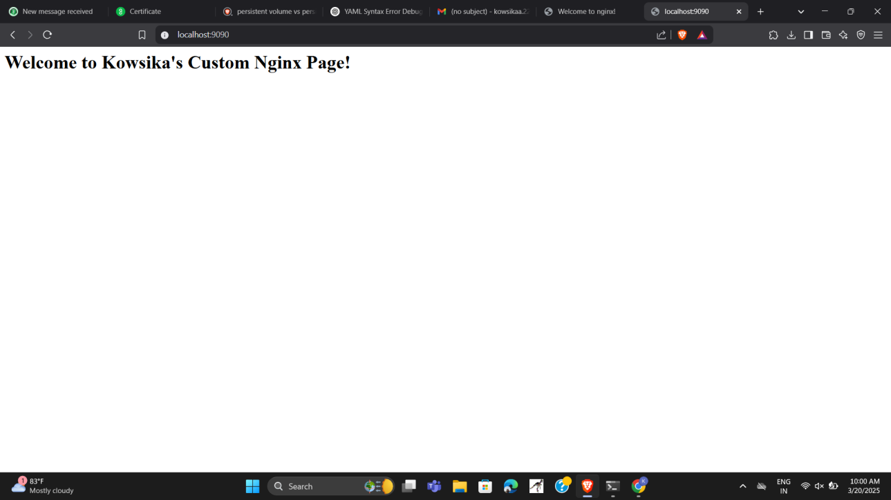

**MINIKUBE & KUBECTL VERSION CHECK:-**

